**OFFICE 365 OFFLINE INSTALLER SOP**

**Step 1:**

**\\bsipl0011\i$\Apps\MS Office\Office365**

Copy the file from above location and paste in **C Drive**

Then follow the below commands to install office 365

**cd c:\Office365**

**setup.exe /configure configuration-Office365-x64.xml**

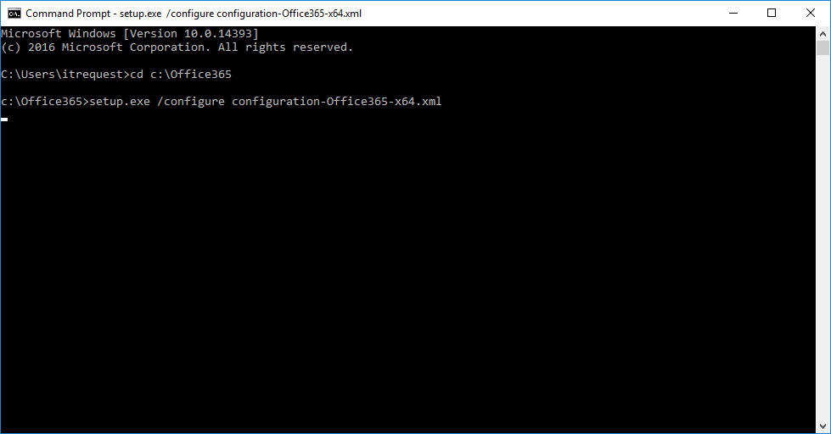

**Wait until the process complete**. Once completed the installation the next line **show c:\Office365**

Then open any office application. It asks office activation. In that time enter users Office 365 credential. Then goto Account check office activation status. If it is not activated close and reopen the application and check.